Task – 11
Docker
List Docker images
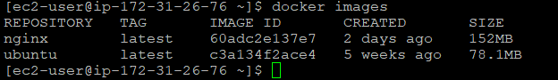

Removed the image
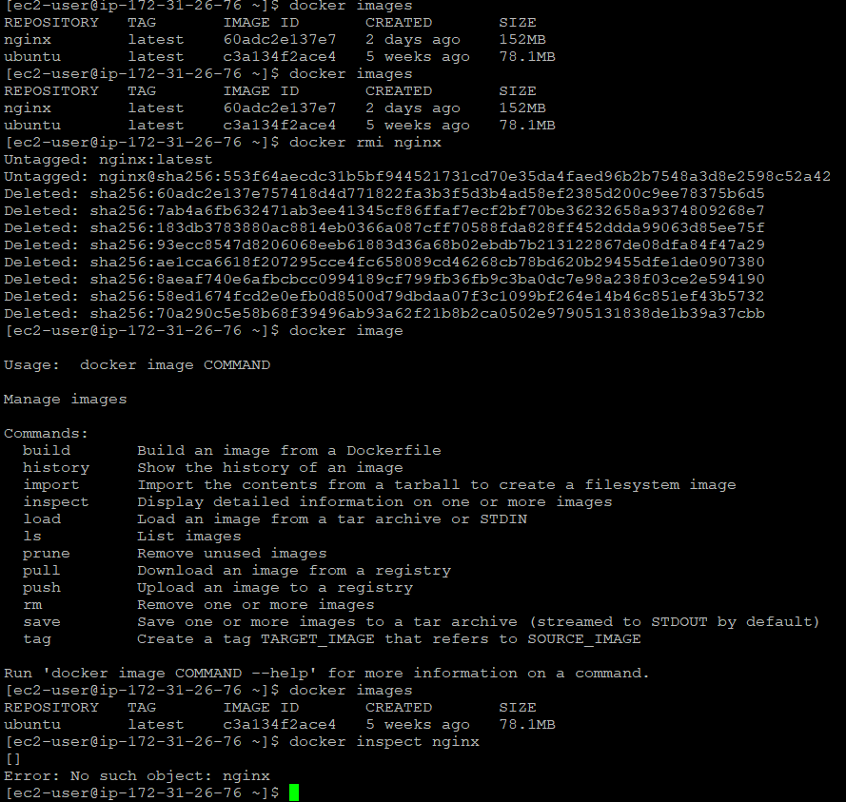

Docker Container
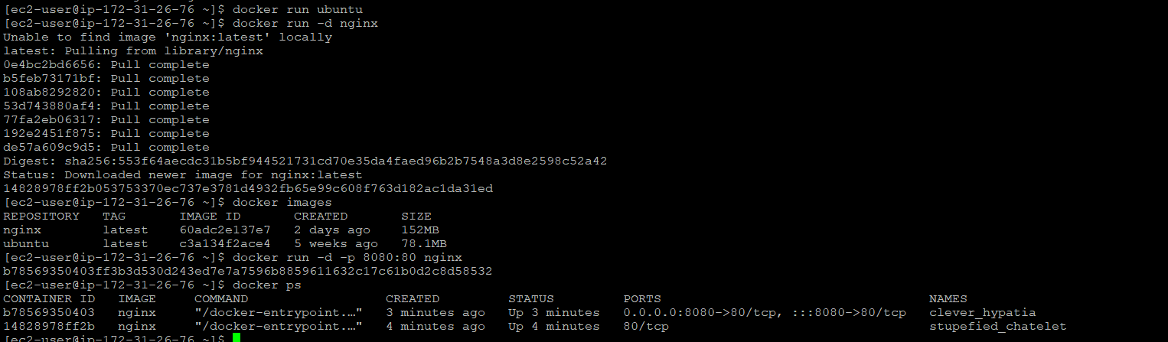
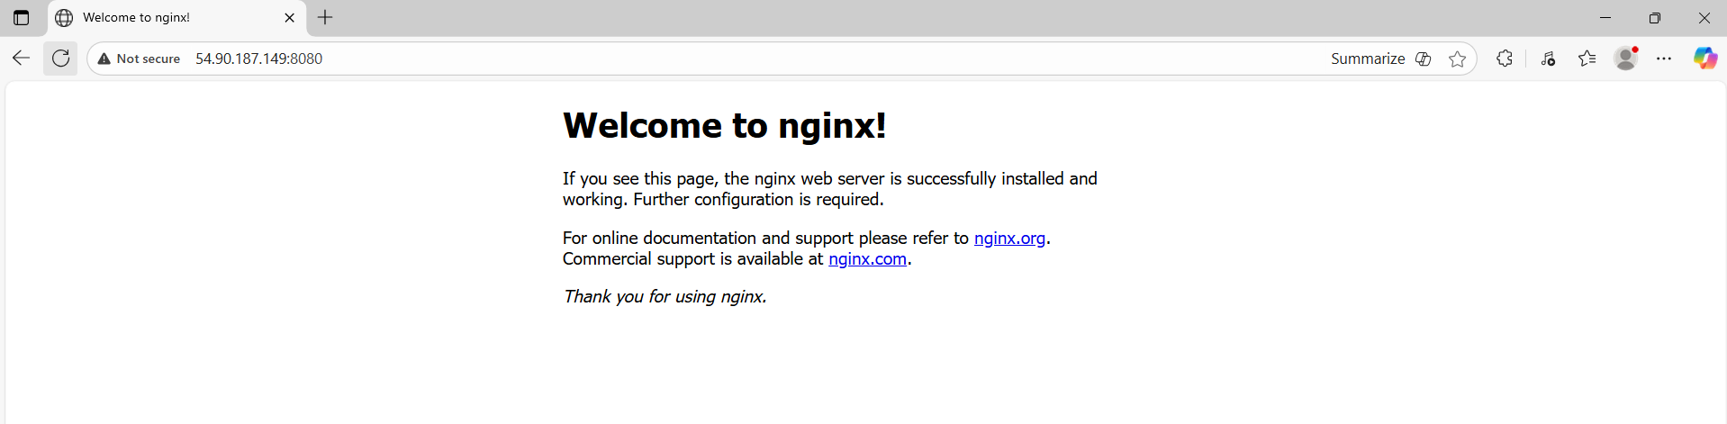

Docker Logs
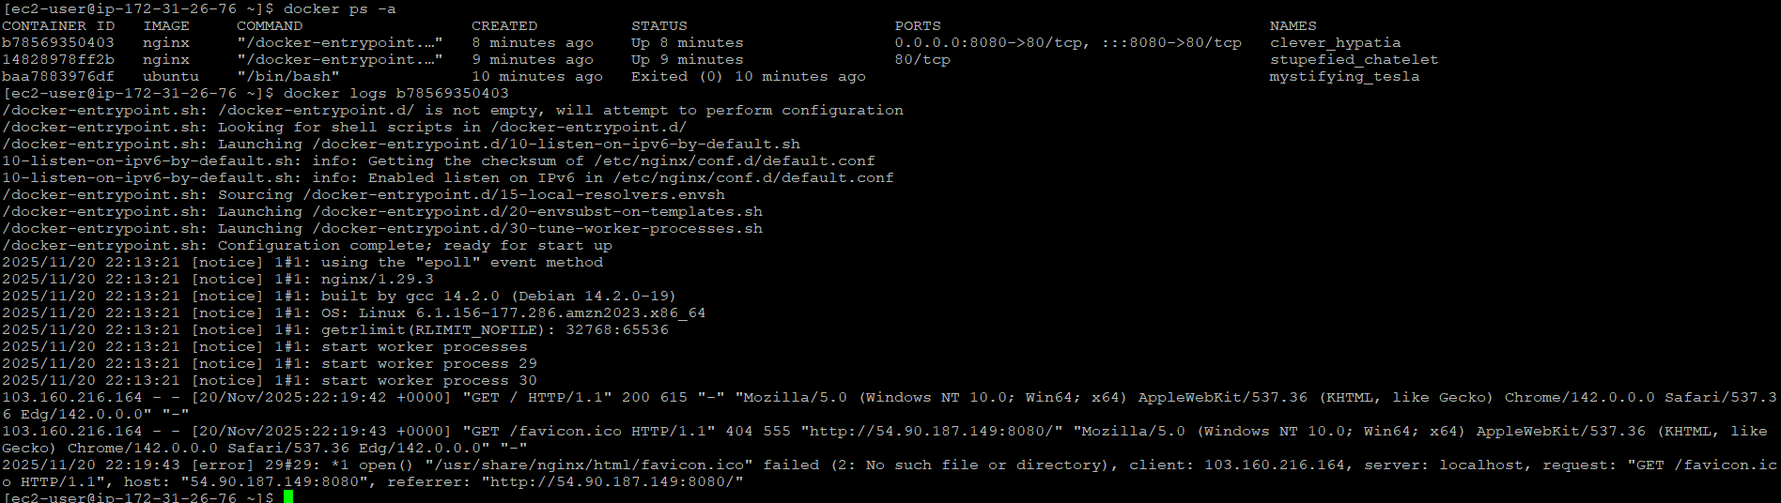

Docker Volume
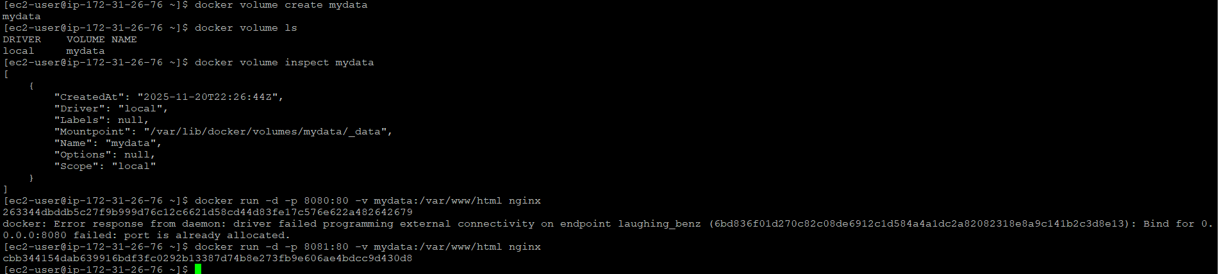
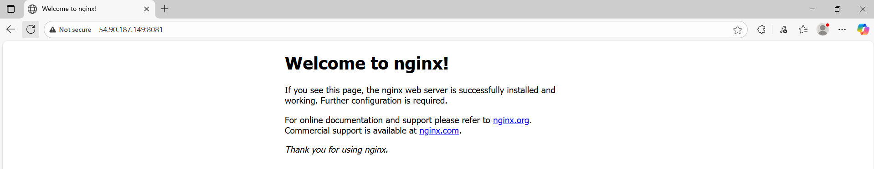

Docker Networks
[ec2-user@ip-172-31-26-76 ~]$ docker network ls
NETWORK ID NAME DRIVER SCOPE
1f96774023d0 bridge bridge local
dd3987d8fc7a host host local
9e257de54bff mynet bridge local
678dad56019e none null local
[ec2-user@ip-172-31-26-76 ~]$ docker run -d --network=mynet --name=app1 nginx
cf172f5a27ed572bec8f902a624e6b6ad5e17787f901f872b6cada066fdba92a
[ec2-user@ip-172-31-26-76 ~]$ docker network inspect mynet
[
{
"Name": "mynet",
"Id": "9e257de54bffe7411f4f329ae14b59c5129f943fe10737dd4b964d6208e36c8e",
"Created": "2025-11-20T22:33:37.48428714Z",
"Scope": "local",
"Driver": "bridge",
"EnableIPv6": false,
"IPAM": {
"Driver": "default",
"Options": {},
"Config": [
{
"Subnet": "172.18.0.0/16",
"Gateway": "172.18.0.1"
}
]
},
"Internal": false,
"Attachable": false,
"Ingress": false,
"ConfigFrom": {
"Network": ""
},
"ConfigOnly": false,
"Containers": {
"cf172f5a27ed572bec8f902a624e6b6ad5e17787f901f872b6cada066fdba92a": {
"Name": "app1",
"EndpointID": "225fdf732a505ac457bdd71db49786ff484f00554356c3e8d8daf58a4a23d87c",
"MacAddress": "02:42:ac:12:00:02",
"IPv4Address": "172.18.0.2/16",
"IPv6Address": ""
}
},
"Options": {},
"Labels": {}
}
]
[ec2-user@ip-172-31-26-76 ~]$ docker exec -it app2 ping app1
Error response from daemon: No such container: app2
[ec2-user@ip-172-31-26-76 ~]$ docker run -d --network=mynet --name=app2 ubuntu sleep infinity
9bfe43cf2575ff23c232ca0a516b48aa2b25815fc9d37035c20a50d26eaa6105
[ec2-user@ip-172-31-26-76 ~]$ docker exec -it app2 ping app1
OCI runtime exec failed: exec failed: unable to start container process: exec: "ping": executable file not found in $PATH: unknown
[ec2-user@ip-172-31-26-76 ~]$ docker exec -it app2 bash
root@9bfe43cf2575:/# apt update
Get:1 http://security.ubuntu.com/ubuntu noble-security InRelease [126 kB]
Get:2 http://archive.ubuntu.com/ubuntu noble InRelease [256 kB]
Get:3 http://security.ubuntu.com/ubuntu noble-security/multiverse amd64 Packages [33.1 kB]
Get:4 http://security.ubuntu.com/ubuntu noble-security/universe amd64 Packages [1174 kB]
Get:5 http://security.ubuntu.com/ubuntu noble-security/main amd64 Packages [1651 kB]
Get:6 http://security.ubuntu.com/ubuntu noble-security/restricted amd64 Packages [2722 kB]
Get:7 http://archive.ubuntu.com/ubuntu noble-updates InRelease [126 kB]
Get:8 http://archive.ubuntu.com/ubuntu noble-backports InRelease [126 kB]
Get:9 http://archive.ubuntu.com/ubuntu noble/restricted amd64 Packages [117 kB]
Get:10 http://archive.ubuntu.com/ubuntu noble/universe amd64 Packages [19.3 MB]
Get:11 http://archive.ubuntu.com/ubuntu noble/multiverse amd64 Packages [331 kB]
Get:12 http://archive.ubuntu.com/ubuntu noble/main amd64 Packages [1808 kB]
Get:13 http://archive.ubuntu.com/ubuntu noble-updates/multiverse amd64 Packages [35.9 kB]
Get:14 http://archive.ubuntu.com/ubuntu noble-updates/restricted amd64 Packages [2903 kB]
Get:15 http://archive.ubuntu.com/ubuntu noble-updates/main amd64 Packages [2041 kB]
Get:16 http://archive.ubuntu.com/ubuntu noble-updates/universe amd64 Packages [1942 kB]
Get:17 http://archive.ubuntu.com/ubuntu noble-backports/main amd64 Packages [49.4 kB]
Get:18 http://archive.ubuntu.com/ubuntu noble-backports/universe amd64 Packages [33.9 kB]
Fetched 34.8 MB in 3s (12.2 MB/s)
Reading package lists... Done
Building dependency tree... Done
Reading state information... Done
All packages are up to date.
root@9bfe43cf2575:/# apt install -y iputils-ping
Reading package lists... Done
Building dependency tree... Done
Reading state information... Done
The following additional packages will be installed:
libcap2-bin libpam-cap
The following NEW packages will be installed:
iputils-ping libcap2-bin libpam-cap
0 upgraded, 3 newly installed, 0 to remove and 0 not upgraded.
Need to get 91.2 kB of archives.
After this operation, 322 kB of additional disk space will be used.
Get:1 http://archive.ubuntu.com/ubuntu noble-updates/main amd64 libcap2-bin amd64 1:2.66-5ubuntu2.2 [34.2 kB]
Get:2 http://archive.ubuntu.com/ubuntu noble-updates/main amd64 iputils-ping amd64 3:20240117-1ubuntu0.1 [44.6 kB]
Get:3 http://archive.ubuntu.com/ubuntu noble-updates/main amd64 libpam-cap amd64 1:2.66-5ubuntu2.2 [12.5 kB]
Fetched 91.2 kB in 0s (1005 kB/s)
debconf: delaying package configuration, since apt-utils is not installed
Selecting previously unselected package libcap2-bin.
(Reading database ... 4381 files and directories currently installed.)
Preparing to unpack .../libcap2-bin_1%3a2.66-5ubuntu2.2_amd64.deb ...
Unpacking libcap2-bin (1:2.66-5ubuntu2.2) ...
Selecting previously unselected package iputils-ping.
Preparing to unpack .../iputils-ping_3%3a20240117-1ubuntu0.1_amd64.deb ...
Unpacking iputils-ping (3:20240117-1ubuntu0.1) ...
Selecting previously unselected package libpam-cap:amd64.
Preparing to unpack .../libpam-cap_1%3a2.66-5ubuntu2.2_amd64.deb ...
Unpacking libpam-cap:amd64 (1:2.66-5ubuntu2.2) ...
Setting up libcap2-bin (1:2.66-5ubuntu2.2) ...
Setting up libpam-cap:amd64 (1:2.66-5ubuntu2.2) ...
debconf: unable to initialize frontend: Dialog
debconf: (No usable dialog-like program is installed, so the dialog based frontend cannot be used. at /usr/share/perl5/Debconf/FrontEnd/Dialog.pm line 79.)
debconf: falling back to frontend: Readline
debconf: unable to initialize frontend: Readline
debconf: (Can't locate Term/ReadLine.pm in @INC (you may need to install the Term::ReadLine module) (@INC entries checked: /etc/perl /usr/local/lib/x86_64-linux-gnu/perl/5.38.2 /usr/local/share/perl/5.38.2 /usr/lib/x86_64-linux-gnu/perl5/5.38 /usr/share/perl5 /usr/lib/x86_64-linux-gnu/perl-base /usr/lib/x86_64-linux-gnu/perl/5.38 /usr/share/perl/5.38 /usr/local/lib/site_perl) at /usr/share/perl5/Debconf/FrontEnd/Readline.pm line 8.)
debconf: falling back to frontend: Teletype
Setting up iputils-ping (3:20240117-1ubuntu0.1) ...
root@9bfe43cf2575:/# ping app1
PING app1 (172.18.0.2) 56(84) bytes of data.
64 bytes from app1.mynet (172.18.0.2): icmp_seq=1 ttl=127 time=0.071 ms
64 bytes from app1.mynet (172.18.0.2): icmp_seq=2 ttl=127 time=0.063 ms
64 bytes from app1.mynet (172.18.0.2): icmp_seq=3 ttl=127 time=0.063 ms
64 bytes from app1.mynet (172.18.0.2): icmp_seq=4 ttl=127 time=0.063 ms
^C
--- app1 ping statistics ---
4 packets transmitted, 4 received, 0% packet loss, time 3080ms
rtt min/avg/max/mdev = 0.063/0.065/0.071/0.003 ms
root@9bfe43cf2575:/#
=
Dockerfile + custom image
